What is Fluency in Maths?

Fluency in maths is about developing number sense and being able to the most appropriate method for the task at hand; to be able to apply a skill to multiple contexts.
The National Curriculum states that pupils should become fluent in the fundamentals of mathematics through varied and frequent practice. While a part of this is about knowing key mathematical facts and recalling them efficiently, fluency means so much more than this as it allows pupils to delve much deeper.

But what are the stages our learners go through in order to become fluent? And how do we decide if a child has attained fluency in a mathematical concept?

Three stages of fluency

- Simple strategies
Initially, as a child gets to grips with a new skill, they can work out an answer using concrete resources or counting strategies. This will probably help them solve a problem accurately, but it’s not the most efficient strategy.

- Mental calculations
As learners become more proficient with new learning, they reach the second stage of fluency. Learners at this stage can work out an answer in their head. It still requires some thinking and effort as they develop reasoning strategies, but they’re well on their way to becoming more efficient.

- Achieving fluency
Finally, children reach the stage of ‘I just knew it’. They can reliably produce accurate answers in an efficient way. This stage often involves using
their knowledge flexibly; making connections so that the known can be used to work out the unknown.

How do we know when a learner is fluent?

You can identify a fluent learner when they have a secure understanding of what they’re doing and why they’re doing it. Fluency is made up of three key parts: efficiency, accuracy and flexibility.

  - Efficiency: learners choose efficient strategies and don’t get bogged down in too many steps
  - Accuracy: learners are accurate in their workings, have great recall of facts and double check their answers
  - Flexibility: learners understand that there are many ways to solve a problem

Fluency means that learners can do more than just memorise procedures. To be truly fluent, a child understands the meaning of the operations and their relationships to each other, they have a large knowledge bank of number facts, and a deep understanding of the base ten system.

How we build fluency in the classroom

At our Primary School, each class uses knowledge organisers for their year groups to help direct the teaching of fluency. Teachers provide fluency activities (remembering red) on a daily or weekly basis and ensure there are visual reminders around the classroom to bring it to the forefront of the children’s minds.

The relevant knowledge organisers are shared with parents, enabling parents to become involved in learning and have a greater understanding of the expectations in maths for their child. By the end of the year, children should know these facts and the aim is for them to achieve true automaticity so they can recall them instantly.

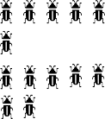
FS Maths Knowledge Mat
Numbers To 20
1
2
3
4
5
6
7
8
9
10
11
12
13
14
15
16
17
18
19
20

Number bonds to 5
1 | 2 | 3 | 4 | 5
0 + 1 | 0 + 2 | 0 + 3 | 0 + 4 | 0 + 5
 | 1 + 1 | 1 + 2 | 1 + 3 | 1 + 4
 |  |  | 2 + 2 | 2 + 3

Quantity To 10
1 |  | 6
2 |  | 7
3 |  | 8 | 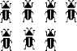
4 |  | 9 | 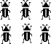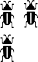
5 |  | 10 | 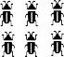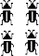

Months Of The Year
January | February | March
April | May | June
July | August | September
October | November | December

Capacity
Empty | Half Full | Full
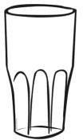 | 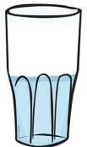 | 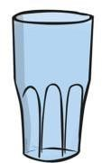

Time
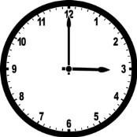 | O’clock The hour hand points to the time and the minute hand points to 12.

Shapes
circle
triangle
square
rectangle

Days of the Week
Monday
Tuesday
Wednesday
Thursday
Friday
Saturday
Sunday

Number | Double
0 | 0
1 | 2
2 | 4
3 | 6
4 | 8
5 | 10

Weight
Heavy / Heavier / Heaviest | 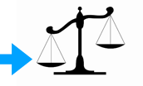
Light / Lighter  / Lightest | 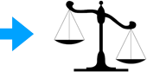
Balanced / Equal | 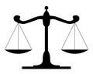

Pattern
Colour |  | blue, red, blue, red
Size |  | big, small, big, small
Length |  | long, short, long, short

Number | Half
0 | 0
2 | 1
4 | 2
6 | 3
8 | 4
10 | 5

Year 1: Maths Knowledge Mat
Numerals and Number Vocabulary
0 | zero | 10 | ten
1 | one | 20 | twenty
2 | two | 30 | thirty
3 | three | 40 | forty
4 | four | 50 | fifty
5 | five | 60 | sixty
6 | six | 70 | seventy
7 | seven | 80 | eighty
8 | eight | 90 | ninety
9 | nine | 100 | one  hundred

Counting
Count forwards and backwards from any number to and across 100
Count in 2s 2, 4, 6, 8, 10, 12…
Count in 5s 5, 10,15, 20, 25, 30…
Count in 10s 10, 20, 30, 40, 50 …
Say the number one more
than…
Say the number one less than…

Number bonds within 20
1 | 1+0
2 | 2+0 1+1
3 | 3+0 2+1
4 | 4+0 3+1 2+2
5 | 5+0 4+1 3+2
6 | 6+0 5+1 4+2 3+3
7 | 7+0 6+1 5+2 4+3
8 | 8+0 7+1 6+2 5+3 4+4
9 | 9+0 8+1 7+2 6+3 5+4
10 | 10+0 9+1 8+2 7+3 6+4 5+5
11 | 11+0 10+1 9+2 8+3 7+4 6+5
12 | 12+0 11+1 10+2 9+3 8+4 7+5 6+6
13 | 13+0 12+1 11+2 10+3 9+4 8+5 7+6
14 | 14+0 13+1 12+2 11+3 10+4 9+5 8+6 7+7
15 | 15+0 14+1 13+2 12+3 11+4 10+5 9+6 8+7
16 | 16+0 15+1 14+2 13+3 12+4 11+5 10+6 9+7 8+8
17 | 17+0 16+1 15+2 14+3 13+4 12+5 11+6 10+7  9+8 8
18 | 18+0 17+1 16+2 15+3 14+4 13+5 12+6 11+7  10+8
19 | 19+0 18+1 17+2 16+3 15+4 14+5 13+6 12+7  11+8 10+9
20 | 20+0 19+1 18+2 17+3 16+4 15+5 14+6 13+7  12+8 11+9 10+10

Doubles, halves and quarters
Number | double | quarter
6 | 12
7 | 14
8 | 16 | 2
9 | 18
10 | 20
Number | half | quarter
12 | 6 | 3
14 | 7
16 | 8 | 4
18 | 9
20 | 10 | 5

Symbols and Vocabulary
+ | plus, add
- | minus, subtract
= | is equal to

Odd and Even
Odd numbers end in 1, 3, 5, 7, 9
Even numbers end in 2, 4, 6, 8, 0

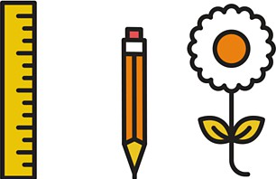
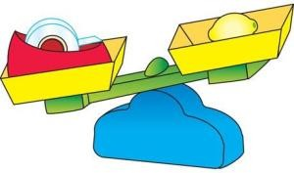
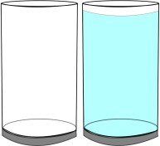
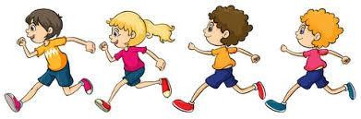
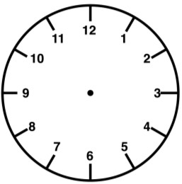
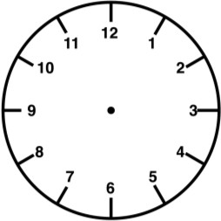
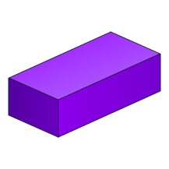
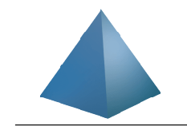
Year 1: Maths Knowledge Mat
Time – Sticky Knowledge
There are 24 hours in a day
There are 60 minutes in an hour
There are 60 seconds in a minute
A.M. means in the morning
P.M. means in the afternoon
O’Clock is when the minute hand points to the 12 and the hour hand points at the hour.
Half past is when the minute hand points to the six and the hour hand points past the hour.

Seven o’clock Half past eleven
Days of the Week  Monday Tuesday Wednesday Thursday Friday Saturday Sunday | Months of the Year  January July February August March September April October  May November  June December

Key Vocabulary - Measurement
long / short longer / shorter tall / short double / half
heavy / light heavier than… lighter than…
full / empty more than… less than…
half full / half empty
quicker / slower before / after first / next
today / yesterday
morning / afternoon / evening

2D Shapes
square
rectangle
circle
triangle

3D Shapes
cube
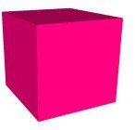
cuboid
sphere

cone
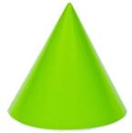
cylinder

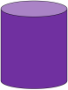
pyramid

Direction and Movement
Whole turn | Half turn | Quarter turn | Three- quarter turn
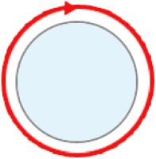 | 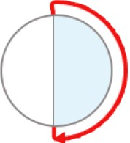 | 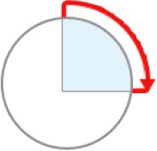 | 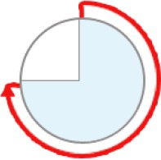

Year 2: Maths Knowledge Mat
Multiplication Tables
x | 2 | 5 | 10
1 | 2 | 5 | 10
2 | 4 | 10 | 20
3 | 6 | 15 | 30
4 | 8 | 20 | 40
5 | 10 | 25 | 50
6 | 12 | 30 | 60
7 | 14 | 35 | 70
8 | 16 | 40 | 80
9 | 18 | 45 | 90
10 | 20 | 50 | 100
11 | 22 | 55 | 110
12 | 24 | 60 | 120

Fractions
½ | a half
¼ | a quarter
¾ | three  quarters
½ = two quarters
You can calculate
fractions of numbers:
½ of 20 is 10.
This is the same as dividing 20 by 2.
¼ of 20 is 5.
This is the same as
dividing 20 by 4.

Addition and multiplication can be done in any order. But subtraction and division can not!
23 + 11 = 34 11 + 23 = 34
3 x 5 = 15 5 x 3 = 15
23 – 11 = 12
But you can not take 23 coins from 11 coins
10 ÷ 5 = 2 5 ÷ 10 = ½

Symbols and Vocabulary
x | multiply, times
÷ | divide
< | is less than
> | is greater than
= | is equal to

2 Digit Place value | Tens | Ones
Example  56 is | 5 | 6
99 | 9 | 9
7 | 0 | 7

Using knowledge of number bonds within 20 (from Year 1) to calculate to at least 100
Examples:
If 3 + 7 = 10 then 30 + 70 = 100
If 6 – 4 = 2 then 60 – 40 = 20

Read and write numbers to at least 100 in numerals and in words
0 | zero | 10 | ten
1 | one | 20 | twenty
2 | two | 30 | thirty
3 | three | 40 | forty
4 | four | 50 | fifty
5 | five | 60 | sixty
6 | six | 70 | seventy
7 | seven | 80 | eighty
8 | eight | 90 | ninety
9 | nine | 100 | one hundred

Counting to at least 100
Count forwards and backwards from any number in steps of 2
Count forwards and backwards
from any number in steps of 3
Count forwards and backwards from any number in steps of 5
Count forwards and backwards from any number in steps of 10

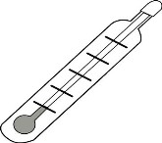
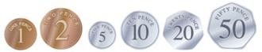
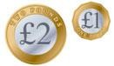
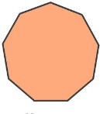
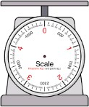
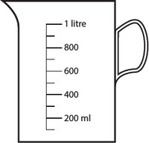
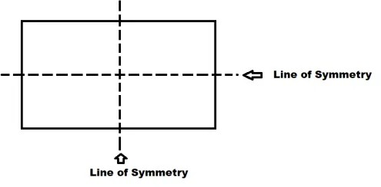
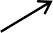
Year 2: Maths Knowledge Mat
Pence p
Pounds £
Coins
Symmetry
Time – Sticky Knowledge
There are 24 hours in a day
There are 60 minutes in an hour and a clock shows these in 5 minute intervals
Quarter to is when the minute hand points to the 9 and the hour hand nearly points at the hour.
Quarter past is when the minute hand points to the three and the hour hand points past just the hour.

Quarter to 12 Quarter past 2

Key Vocabulary - Measurement
Metre m
Centimetre cm
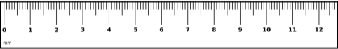
Kilogram kg Gram g
Litre l
Millilitre ml
Degrees centigrade °c

2D Shapes
Quadrilaterals have four sides

Parallelogram Isosceles Trapezoid Rectangle

Square Trapezoid Rhombus Kite
A polygon is a 2D shape with straight sides

Triangle Quadrilateral Pentagon Hexagon

Heptagon Octagon Nonagon Decagon

3D Shapes
Faces, edges and vertices
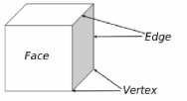

Direction
Quarter turn is 1 right angle
¾ turn is 3 right angles

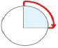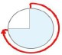

Year 3: Maths Knowledge Mat
Equivalent Fractions
Examples:
1
2
5
10
=
=
2
4
4
8
Adding fractions
3 2 5
8 8 8
+ =
Fractions
Counting from 0
Counting in multiples of 4
0, 4, 8, 12, 16, 20, 24, 28, 32…
Counting in multiples of 8
0, 8, 16, 24, 32, 40, 48…
Counting in multiples of 50
0, 50, 10, 150, 20, 250, 300…
Counting in multiples of 100
0, 100, 200, 300, 400, 500…

Place value | Thousands | Hundreds | Tens | Ones |  | Tenths
1238 | 1 | 2 | 3 | 8 |  | 0
58.9 | 0 | 0 | 5 | 8 |  | 9
3050.4 | 3 | 0 | 5 | 0 |  | 4

Multiplication Tables
x | 3 | 4 | 8
1 | 3 | 4 | 8
2 | 6 | 8 | 16
3 | 9 | 12 | 24
4 | 12 | 16 | 32
5 | 15 | 20 | 40
6 | 18 | 24 | 48
7 | 21 | 28 | 56
8 | 24 | 32 | 64
9 | 27 | 36 | 72
10 | 30 | 40 | 80
11 | 33 | 44 | 88
12 | 36 | 48 | 96

1
𝟏  𝟐 |  |  |  |  |  |  |  |  |  | 𝟏  𝟐
𝟏  𝟑 |  |  |  |  |  |  | 𝟏  𝟑 |  |  |  |  |  | 𝟏  𝟑
𝟏  𝟒 |  |  |  |  | 𝟏  𝟒 |  |  |  |  | 𝟏  𝟒 |  |  |  |  | 𝟏  𝟒
𝟏  𝟓 |  |  |  | 𝟏  𝟓 |  |  |  |  | 𝟏  𝟓 |  | 𝟏  𝟓 |  |  |  |  | 𝟏  𝟓
𝟏  𝟔 |  |  | 𝟏  𝟔 |  |  |  | 𝟏  𝟔 |  |  | 𝟏  𝟔 |  |  | 𝟏  𝟔 |  |  |  | 𝟏  𝟔
𝟏  𝟖 |  | 𝟏  𝟖 |  |  | 𝟏  𝟖 |  |  | 𝟏  𝟖 |  | 𝟏  𝟖 |  | 𝟏  𝟖 |  |  | 𝟏  𝟖 |  |  | 𝟏  𝟖
𝟏  𝟏𝟎 | 𝟏  𝟏𝟎 |  |  | 𝟏  𝟏𝟎 |  | 𝟏  𝟏𝟎 |  |  | 𝟏  𝟏𝟎 | 𝟏  𝟏𝟎 | 𝟏  𝟏𝟎 |  |  | 𝟏  𝟏𝟎 |  | 𝟏  𝟏𝟎 |  |  | 𝟏  𝟏𝟎

Vocabulary
100 | hundred
1000 | thousand
+ -  X ÷ | inverse operations
𝟏  𝟐 | Numerator
𝟏  𝟐 | Denominator

Formal methods of addition, subtraction and short multiplication and division
768 + 653 becomes |  |  |  | 862 - 514 becomes |  |  |  | 934 - 456 becomes |  |  |  | 26 x 8 becomes |  |  | 78 ÷ 6 becomes
 |  |  |  |  |  |  |  |  | 8 | 12 | 1 |  |  |  |  | 1 | 3
 | 7 | 6 | 8 |  | 8 | 6 | 2 |  | 9 | 3 | 4 |  | 2 | 6 |  |  | 1
+ | 6 | 5 | 3 | - | 5 | 1 | 4 | - | 4 | 5 | 6 | x |  | 8 | 6 | 7 | 8
1 | 4 | 2 | 1 |  | 3 | 4 | 8 |  | 4 | 7 | 8 | 2 | 0 | 8
 | 1 | 1 |  |  |  |  |  |  |  |  |  |  | 4

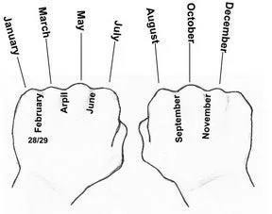
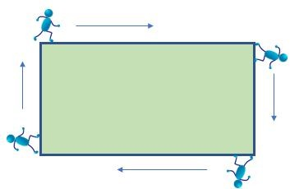


Year 3: Maths Knowledge Mat
Non symmetrical (irregular) polygons
Time | – | Sticky Knowledge
24 hour clocks |  |  | Roman numerals
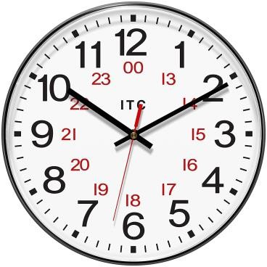 |  |  | 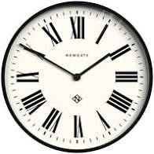
The time is 10.10 in the morning or  22.10 in the evening in 24 hour time. |  |  | This clock is showing X to II or 10 to 2.  On some clocks the 4 is IIII and sometimes it is IV
a.m. is from midnight until mid-day  (noon)  1 to 12 in 24 hour clock time |  |  | p.m. is from mid-day (noon) until  midnight  13 to 24 in 24 hour clock time
There are 365 days in a year.
A leap year has 366 days. This is February 29th and happens every 4 years.
January 31 days  February 28 days  March 31 days  April 30 days  May 31 days  June 30 days  July 31 days  August 31 days  September 30 days  October 31 days  November 30 days  December 31 days | ‘Knuckle Mnemonic’

Polygon/Shape | Regular | Irregular
Triangle | 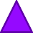
Quadrilateral |  | 
Pentagon | 
Hexagon | 
Heptagon
Octagon

Lines
Parallel

Perpendicular

Angles
 |  |  | Obtuse angle  More than 90°  Less than 180° | 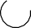  Reflex angle  More than 180°  Less than 360°
Acute angle |  | Right angle | Obtuse angle  More than 90°  Less than 180°
Less than 90° |  | Exactly 90° | Obtuse angle  More than 90°  Less than 180°

Perimeter
Perimeter is the distance around a 2D shape
32m

20m 20m

32m

Year 4: Maths Knowledge Mat
Counting from 0
Counting in multiples of 6
0, 6, 12, 18, 24, 30, 36, 42 …
Counting in multiples of 7
0, 7, 14, 21, 38, 35, 42, 49…
Counting in multiples of 9
0, 9, 18, 27, 36, 45, 54, 63 …
Counting in multiples of 25
0, 25, 50, 75, 100, 125, 150…
Counting in multiples of 1000
0, 1000, 2000, 3000, 4000…
Counting up and down in
hundredths
𝟏 , 𝟐 , 𝟑 , 𝟒 … … . 𝟗𝟗 , 1
𝟏𝟎𝟎 𝟏𝟎𝟎 𝟏𝟎𝟎 𝟏𝟎𝟎 𝟏𝟎𝟎
A thousand more than 4753 is 5753.
A thousand less than 4753 is
3753.

Rounding |  | Negative  Numbers
31 32 33 34 36 37 38 39  30 35 40  The numbers below The numbers above  half way all ROUND half way all ROUND DOWN to 30 UP to 40  The number in the middle is half way and ROUNDS UP to 40  Rounding to 100 and 1000 follows the same rule.  350 rounds up to 400  3500 rounds up to 4000  Rounding decimal places also follows the same rule.  3.4 rounds to 3.0 but 3.5 rounds to 4.0  3.04 rounds to 3.00 but 3.05 rounds to  3.10 |  | Negative  Numbers
10
9
8
7
6
Numbers above 0
5 (zero) are positive
4
3
2
1
0
-1
-2
-3
-4
-5 Numbers below 0
(zero) are negative
-6
-7
-8
-9
-10
 | Roman Numerals | Factors  A factor pair is a pair of numbers that, when multiplied will result in a given product.  Factor pairs of  16 are  1 , 16  2 , 8  4 , 4
1 = I 10 = X
2 = II 20 = XX
3 = III 30 = XXX
4 = IV 40 = XL
5 = V 50 = L
6 = VI 60 = LX
7 = VII 70 = LXX
8 = VIII 80 = LXXX
9 = IX 90 = XC
100 = C

Multiplication Tables
(and 2x,3x,4x,5x,8x,10x from previous years)
x | 6 | 7 | 9 | 11 | 12
1 | 6 | 7 | 9 | 11 | 12
2 | 12 | 14 | 18 | 22 | 24
3 | 18 | 21 | 27 | 33 | 36
4 | 24 | 28 | 36 | 44 | 48
5 | 30 | 35 | 45 | 55 | 60
6 | 36 | 42 | 54 | 66 | 72
7 | 42 | 49 | 63 | 77 | 84
8 | 48 | 56 | 72 | 88 | 96
9 | 54 | 63 | 81 | 99 | 108
10 | 60 | 70 | 90 | 110 | 120
11 | 66 | 77 | 99 | 121 | 132
12 | 72 | 84 | 108 | 132 | 144

Formal methods of short multiplication and division
351 x 7 becomes  3 5 1  x 7  2 4 5 7  2 3 | 91 ÷ 7 becomes  1 3  2  7 9 1

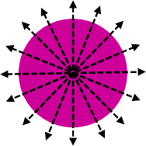

Year 4: Maths Knowledge Mat
1 line of symmetry 3 lines of symmetry
4 lines of symmetry Infinite number of lines of
symmetry
Symmetry
Simplifying fractions
40 =  80 | 20 =  40 | 10 =  20 | 5  10 | = | 1  2 | So | ⁴⁰= 0.5  80

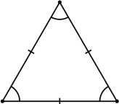
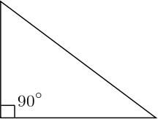
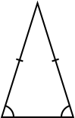
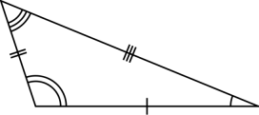
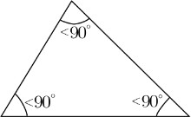
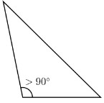
 | Tens | Ones |  | tenths | hundredths
45 | 4 | 5 |  | 0 | 0
4.5 = 4 ⁵ = 4¹  10 2 | 0 | 4 |  | 5 | 0
0.45 = ⁴⁵  100 | 0 | 0 |  | 4 | 5

The area of this shape
EQUALS
the area of these two
2 cm
2 cm
6 cm
3 cm
6 cm
3 cm
6 cm
The area of this shape
6 cm
= (6 X 6) + (2 X 3)
= 36 + 6

6
= 42
Area
Time – Sticky Knowledge
Digital and analogue clocks
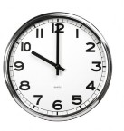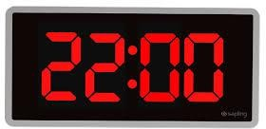
Both clocks show it is 10 o’clock. But only the digital clock shows that it is pm (in the evening) because it is using 24 hour time.
2D Shapes
Rhombus Trapezium
(or trapezoid)

All four sides are the Two sides are parallel. same length, like a Side lengths and square that has been angles are not equal. squashed sideways.
Coordinates
5 XD X axis comes first, so  4 XC  3 A = (0,2)  2 XA X E B = (1,0)  C = (2,4)  1 D = (5,5)  0 XB E = (4,2)  0 1 2 3 4 5  Origin |  | 8  7 B  This shape  6 A C has been  5 B translated  up and left  4 D by  3 A C -3, -3.  (Taken away  2 from each  1 D co- cordinate.)  0 1 2 3 4 5 6 7 8

Obtuse Triangle
Acute Triangle
Scalene Triangle
Isosceles Triangle
Right Triangle
Equilateral Triangle
Triangles

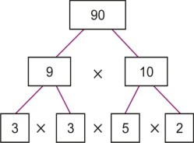
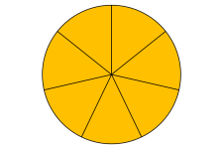
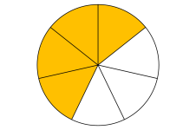
Year 5: Maths Knowledge Mat
11
7
Prime factors
7
4
Converting a mixed number to an improper fraction
1 =
Rounding
78,543
To the nearest 10 is 78,540
To the nearest 100 is 78,500
To the nearest 1000 is 79,000
To the nearest 10,000 is 80,000
To the nearest 100,000 is 100,000
67.53
To the nearest 10 is 70
To the nearest whole number is 68
To one decimal place is 67.6

 |  |  |  | Multiplying a fraction by a whole number
If you have a proper fraction multiplied by a whole number, it is going to be less than that whole number
3 x 2
5
3 x 2 = 6 = 1 1
5 1 5 5
Place value  Each row divides  by 10 | Tens | Ones |  | tenths | hundredths | thousandths
36.7 | 3 | 6 |  | 7 | 0 | 0
3.67 | 0 | 3 |  | 6 | 7 | 0
0.367 | 0 | 0 |  | 3 | 6 | 7
36.7 = 36 ⁷ 3.67 = 3 ⁶⁷ 0.367 = ³⁶⁷
10 100 1000

Prime Numbers
 | 1 | 2 | 3 | 4 | 5 | 6 | 7 | 8 | 9 | 10
 | 11 | 12 | 13 | 14 | 15 | 16 | 17 | 18 | 19 | 20
 | 21 | 22 | 23 | 24 | 25 | 26 | 27 | 28 | 29 | 30
 | 31 | 32 | 33 | 34 | 35 | 36 | 37 | 38 | 39 | 40
 | 41 | 42 | 43 | 44 | 45 | 46 | 47 | 48 | 49 | 50
 | 51 | 52 | 53 | 54 | 55 | 56 | 57 | 58 | 59 | 60
 | 61 | 62 | 63 | 64 | 65 | 66 | 67 | 68 | 69 | 70
 | 71 | 72 | 73 | 74 | 75 | 76 | 77 | 78 | 79 | 80
 | 81 | 82 | 83 | 84 | 85 | 86 | 87 | 88 | 89 | 90
 | 91 | 92 | 93 | 94 | 95 | 96 | 97 | 98 | 99 | 100
Percentages %
‘part per hundred’ 50% = ^{𝟓𝟎} 25% = ^{𝟐𝟓}
𝟏𝟎𝟎 𝟏𝟎𝟎
50% of 100 = 50 25% of 100 = 25
50% of 200 = 100 25% of 200 = 50
50% of 300 = 150 25% of 300 = 75

¹ = 0.5 = 50% ¹ = 0.25 = 25%
2 4
¹ = 0.2 = 20% ² = 0.4 = 40%
5 5

Formal methods of multiplication and division
3741 x 6 becomes | 485 ÷ 11 becomes | 34 x 26 becomes | 134 x 27 becomes  2 2  1 3 4  X 2 7  2 6 8 0  9 3 8  3 6 1 8  1 1
 |  | 2
3 7 4 1 | 4 4 r1 | 3 4
X 6 | 4 | X 2 6
2 2 4 4 6 | 11 4 8 5 | 6 8 0
4 2 |  | 2 0 4
 |  | 8 8 4

Square and cubed numbers | 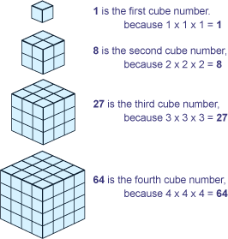
1² = 1 x 1 = 1
2² = 2 x 2 = 4
3² = 3 x 3 = 9
4² = 4 x 4 = 16
5² = 5 x 5 = 25
6² = 6 x 6 = 36
7² = 7 x 7 = 49
8² = 8 x 8 = 64
9² = 9 x 9 = 81
10² = 10 x 10 = 100

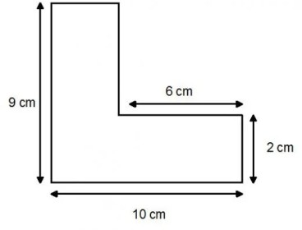
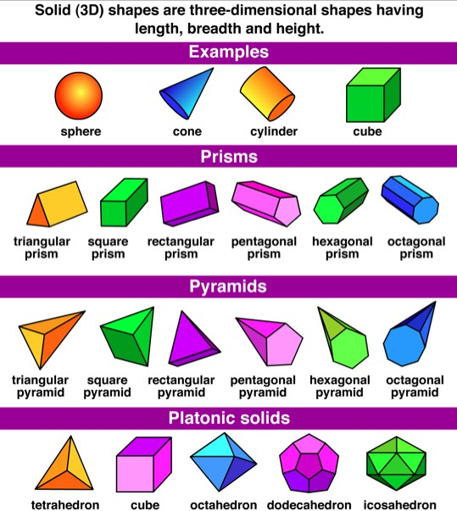
Year 5: Maths Knowledge Mat
Dates
2020 = MMXX
2021 = MMXXI
2022 = MMXXII
2023 = MMXXIII
2024 = MMXXIV
1066 = MLXVI
1939 = MCMXXXIX
Roman Numerals
3D Shapes
Angles
Right angle Straight line
Exactly 90° = 180° Complete turn
= 360°

Acute angle Reflex angle
Less than 90° Obtuse angle greater than 180° Between 90°
and 180°
 | Using a protractor | 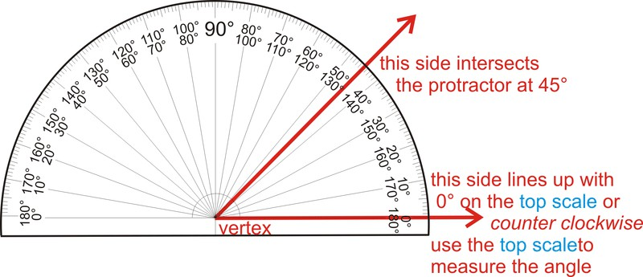
 | Coordinates
 | P has been reflected in the x axis  3  2  p(2,2)  1  -3 -2 -1 1 2 3  -1  -2  p(2,-2)  -3 |  | The shape has been reflected in the dotted line y=x+2  7  6  5  4  3  2  1  0  1 2 3 4 5 6 7

Symbol | Value
I | 1
V | 5
X | 10
L | 50
C | 100
D | 500
M | 1000

Measures – Sticky Knowledge
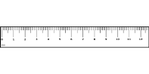  1 km = 1000 m  1 m = 100 cm  1 cm = 10 mm  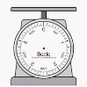  1 kg = 1000 g  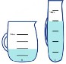  1 l = 1000 ml | Imperial  measures  1 mile = 1.6 km I yard = 0.91 m 1 foot = 30 cm  1 inch = 2.54 cm  1 lb (pound) =  0.45 kg  1 pint = 0.57 litre

Perimeter
This must be 4 cm (10cm – 6cm)

This must be 7cm
(9cm – 2cm)

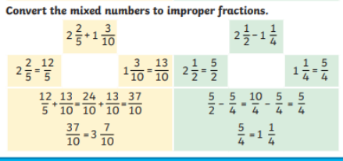
Year 6: Maths Knowledge Mat
On a calculator
36% of 76
0.36 x 76
Change to a decimal and multiply
Fraction to %
x5
15 75
20 100
x5
= = 75%
Or 15÷20 x 100 = 75%
Without a calculator
50% - half
25% - half and half 75% - 50% + 25%
10% - divide by 10
5% - half 10%
20% - double 10%
Percentages
Decreasing
Decrease £70 by 14%
14% of 70 = 0.14 x 70 = £9.80
New amount = £70 - £9.80
=£60.20
Increasing
Increase £70 by 14%
14% of 70 = 0.14 x 70 = £9.80
New amount = £70 + £9.80
=£79.80
=
x =
𝟓 𝟖 𝟓 x 𝟕 𝟑𝟓
𝟏𝟖
𝟑 𝟔 𝟑 x 𝟔
Multiplying a fraction by a fraction
x =
𝟏
𝟒
= = reduces to
𝟒 𝟑 𝟒 x 𝟑 𝟏𝟐
𝟑 𝟏 𝟑 x 𝟏 𝟑
(2²)
(Multiply 5 x 4)
(Add 20 + 7)
40 – (5 x 4 + 7)
40 – (20 + 7)
40 - 27
Answer = 13
B → Bracket O → Of
D → Division
M → Multiplication A → Addition
S → Subtraction
--------------------------------------------------
BODMAS EXAMPLE
40 – (5 x 2² + 7)
Brackets 1st then use ODMAS inside the brackets
BODMAS
Ratio compares values.
A ratio says how much of one thing there is compared to another thing. Ratio 3:1. There
are 3 blue
squares to 1 yellow square.
Ratio
The sum of all data points divided by the number of data points
Mean Average
8,378,543
To the nearest 10,000 is 8,380,000
To the nearest 100,000 is 8.400,000
To the nearest 1,000,000 is 8,000,000
To the nearest 10,000,000 is 10,000,000
Rounding
Calculations with mixed numbers |  | Adding fractions
^{𝟏} + ^{𝟏} = ?
𝟐 𝟑
1 x 3= 3 1 x 2= 2
2 x 3 6 3 x 2 6
3 + 2 = 5
6 6 6

Formal methods of multiplication and division
134 x 27 becomes | 564 ÷ 15 becomes  15 5 6 4  4 5 0 15 X 30  1 1 4  1 0 5 15 X 7  3 7  𝟗 = 𝟑  𝟏𝟓 𝟓  Answer: 37 ^{𝟑}  𝟓 | 432 ÷ 15 becomes | 384 ÷ 11 becomes  3 4 r10  5  11 3 8 4  Answer: 34 ^{𝟏𝟎}  𝟏𝟏
2 2 |  | 2 8 . 8 | 384 ÷ 11 becomes  3 4 r10  5  11 3 8 4  Answer: 34 ^{𝟏𝟎}  𝟏𝟏
1 3 4 |  | 15 4 3 2 . 0  3 0 | 384 ÷ 11 becomes  3 4 r10  5  11 3 8 4  Answer: 34 ^{𝟏𝟎}  𝟏𝟏
X 2 7 |  | 1 3 2 | 384 ÷ 11 becomes  3 4 r10  5  11 3 8 4  Answer: 34 ^{𝟏𝟎}  𝟏𝟏
2 6 8 0 |  | 1 2 0  1 2 0 | 384 ÷ 11 becomes  3 4 r10  5  11 3 8 4  Answer: 34 ^{𝟏𝟎}  𝟏𝟏
9 3 8 |  | 1 2 0 | 384 ÷ 11 becomes  3 4 r10  5  11 3 8 4  Answer: 34 ^{𝟏𝟎}  𝟏𝟏
3 6 1 8  1 1 |  | 0  Answer: 28.8 | 384 ÷ 11 becomes  3 4 r10  5  11 3 8 4  Answer: 34 ^{𝟏𝟎}  𝟏𝟏

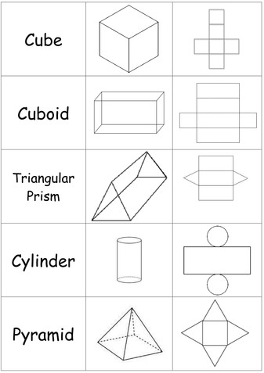
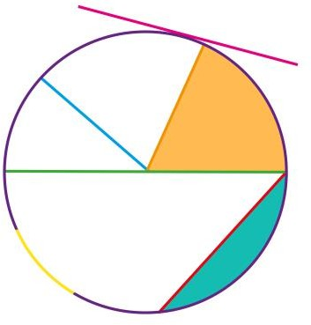

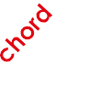
Year 6: Maths Knowledge Mat
Nets of 3D shapes
Circles
Sector
diameter

circumference
The diameter is twice the
radius

Angles in a triangle
a° b°
a° + b° + c° = 180°
c°

38° 48°
38° + 60° + c° = 180°
c° = 180° - 98
c° = 82°

Square Numbers |  | Square Roots
12 | 1 | √1 | 1
22 | 4 | √4 | 2
32 | 9 | √9 | 3
42 | 16 | √16 | 4
52 | 25 | √25 | 5
62 | 36 | √36 | 6
72 | 49 | √49 | 7
82 | 64 | √64 | 8
92 | 81 | √81 | 9
102 | 100 | √100 | 10
112 | 121 | √121 | 11
122 | 144 | √144 | 12
132 | 169 | √169 | 13

Cube Numbers |  | Cube Roots
13 | 1 | √1 | 1
23 | 8 | √8 | 2
33 | 27 | √27 | 3
43 | 64 | √64 | 4
53 | 125 | √125 | 5

Vocabulary
factors | numbers that you multiply together to get other numbers
multiple | the result of multiplying a number by  an integer
HCF | Highest Common Factor - the largest factor shared by two or more numbers
LCM | Lowest Common Multiple - the smallest number that is a multiple of two or more numbers.

Area of a Triangle
Area = ¹ x b x h = bh
2 2

h

b
Volume
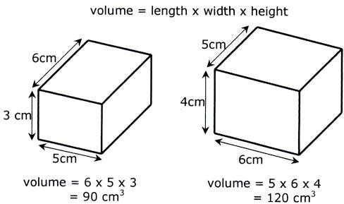
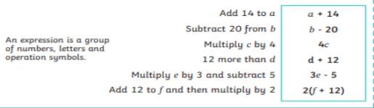

Algebra

